Backlink Performance Analysis (Sep’ 26 )

Source
Semrush, GSC, Moz

URLs Tracked
15
Total pages monitored

Keywords Tracked
35
Total keywords monitored
Plan Total Backlinks (Till Sep)
455
Actual Total Backlinks (Till Sep)
421

Business Impact of Backlinks
Source: GSC
Sep’26
remote desktop - 12
remote desktop software - 22
remote access - 5
remote access software - 101
remote support - 11
remote support software - 101

teamviewer alternative - 2
teamviewer pricing - 4
logmein alternative - 9
logmein pricing - 44
anydesk alternative - 9
anydesk pricing - 4
patch management - 5
patch management software - 101
autonomous endpoint management - 5

Dec’25
remote desktop - 12
remote desktop software - 20
remote access - 7
remote access software - 13
remote support - 8
remote support software - 12
teamviewer alternative - 7
teamviewer pricing - 20
logmein alternative - 22
logmein pricing - 11
anydesk alternative - 20
anydesk pricing - 8
patch management - 62
patch management software - 101
autonomous endpoint management - 14

Add this KeyTakeaway:
Informational keywords continue to deliver strong visibility, with 'remote access (5)' securing a top 5 position, while 'remote desktop (12)' and 'remote support (11)' maintain stable rankings.

Competitor keywords continue to strengthen, with 5 out of 6 keywords ranking in the top 10 positions, including 3 keywords ranking in the top 5.
Patch management and endpoint management keywords continue to show strong performance, with 2 out of 3 keywords ranking in the top 5 positions.

Referring Domains DA

Here are the Referring DA categories of the given backlinks
Referring Domain DA
DA 71 - 100 - 62
DA 41-70 - 317
DA 25 -40 - 42

Monthly Backlink Growth

Backlink monthly growth trend
Feb’ 26 Mar’26 Apr’26 May’26 June’26 July’26 Aug’ Sep,26
Total Backlinks
50 25 48 83 32 108 35 40

Keyword Ranking Performance

Keywords in Top 5

Dec’25 - 0
Sep’26 - 6

Dec’25

remote access - 7
teamviewer alternative - 7
teamviewer pricing - 20
anydesk pricing - 8
patch management - 62
autonomous endpoint management - 14

Sep’26
remote access – 5
teamviewer alternative – 2
teamviewer pricing – 4
anydesk pricing – 4
patch management – 5
autonomous endpoint management – 5

Keywords on First Page (Top 10)
Dec‘25 - 4
Sep’26- 8

Dec’25
remote access - 7
logmein alternative -22
teamviewer alternative - 7
teamviewer pricing - 20
anydesk pricing - 8
anydesk alternative - 20
patch management - 62
autonomous endpoint management - 14

Sep’26
remote access – 5
teamviewer alternative – 2
teamviewer pricing – 4
logmein alternative – 9
anydesk alternative – 9
anydesk pricing – 4
patch management – 5
autonomous endpoint management – 5

Tracked URLs
- https://www.splashtop.com/blog/what-is-remote-desktop
- https://www.splashtop.com/solutions/remote-desktop
- https://www.splashtop.com/blog/what-is-remote-access
- https://www.splashtop.com/products/remote-access
- https://www.splashtop.com/blog/what-is-remote-support
- https://www.splashtop.com/products/remote-support
- https://www.splashtop.com/compare/teamviewer-alternative
- https://www.splashtop.com/blog/teamviewer-pricing-comparison
- https://www.splashtop.com/compare/logmein-alternative
- https://www.splashtop.com/compare/logmein-alternative/pricing
- https://www.splashtop.com/compare/anydesk-alternative
- https://www.splashtop.com/blog/anydesk-pricing-comparison
- https://www.splashtop.com/blog/what-is-patch-management
- https://www.splashtop.com/solutions/patch-management
- https://www.splashtop.com/blog/autonomous-endpoint-management-comprehensive-guide

Performance Summary

 | "Baseline  Dec'25" | FeFeb'26 | Mar'26 | Apr'26 | May’26 | June’26 | July’26 | Aug’26 | Sep’26
Total Backlinks | - | 3 | 8 | 11 | 20 | 23 | 29 | 32 | 35
Remote Access | 7 | 6 | 7 | 5 | 6 | 4 | 5 | 5 | 5
What is remote access | 8 | 6 | 6 | 4 | 3 | 3 | 3 | 4 | 3
benefits of remote access | 2 | 3 | 2 | 2 | 3 | 3 | 3 | 3 | 3
remote desktop access | - | 20 | 18 | 11 | 21 | 10 | 8 | 9 | 11
Page Authority | 43 | 44 | 44 | 44 | 44 | 44 | 44 | 44 | 44

 | "Baseline  Dec'25" | Feb'26 Feb'26 | Mar'26 | Apr'26 | May’26 | June’26 | July,26 | Aug’26 | Sep’26
Total Backlinks | - | 3 | 5 | 8 | 16 | 21 | 34 | 35 | 39
remote support | 8 | 12 | 13 | 22 | 14 | 10 | 6 | 10 | 11
what is remote support | 3 | 3 | 3 | 4 | 4 | 4 | 3 | 3 | 3
remote desktop support | 17 | 12 | 9 | 20 | 17 | 16 | 19 | 22 | 14
Page Authority | 33 | 38 | 38 | 40 | 42 | 42 | 42 | 42 | 42

 | "Baseline  Dec'25" | Feb'26 Feb'26 | Mar'26 | Apr'26 | May’26 | June’26 | July’26 | Aug’26 | Sep’26
Total Backlinks | - | 12 | 15 | 29 | 43 | 47 | 61 | 69 | 73
Remote access software | 13 | 1 | 1 | 1 | 6 | 101 | 101 | - | -
Remote Access Solution | 4 | 1 | 1 | 1 | - | 101 | 101 | - | -
remote access tool | 11 | - | - | - | - | - | 101 | - | -
Page Authority | 43 | 46 | 46 | 47 | 47 | 47 | 47 | 48 | 48

 | "Baseline  Dec'25" | Feb'26 Feb'26 | Mar'26 | Apr'26 | May’26 | June’26 | July’26 | Aug’26 | Sep’26
Total Backlinks | - | 14 | 23 | 27 | 38 | 41 | 59 | 62 | 72
Remote support software | 12 | 11 | 82 | 5 | 1 | - | 101 | - | -
Remote Support Solution | 4 | 17 | 2 | 3 | 1 | - | 101 | - | -
remote support tool | 9 | 7 | - | - | 1 | - | 101 | - | -
remote it support software | 8 | 7 | - | - | - | - | 101 | - | -
Page Authority | 45 | 47 | 47 | 47 | 48 | 48 | 48 | 48 | 48

 | "Baseline  Dec'25" | Feb'26 Feb'26 | Mar'26 | Apr'26 | May’26 | June’26 | July’26 | Aug’26 | Sep’26
Total Backlinks | - | 11 | 14 | 26 | 38 | 44 | 63 | 71 | 76
Remote desktop software | 20 | 40 | 15 | 13 | 11 | 15 | 28 | 31 | 22
Remote desktop Solution | 32 | 53 | 25 | 24 | 31 | 22 | 17 | 18 | 10
remote desktop connection software | 37 | 36 | 21 | 24 | 27 | 32 | 16 | 27 | 26
remote pc software | 38 | 56 | 24 | 18 | 40 | 45 | 44 | 39 | 23
remote desktop program | 48 | 39 | 18 | 13 | 9 | 16 | 26 | 28 | 20
remote desktop tools | 26 | 35 | 11 | 6 | 25 | 17 | 11 | 10 | 7
Remote Desktop | 12 | 42 | 29 | 27 | 27 | 15 | 5 | 6 | 9
Page Authority | 45 | 45 | 45 | 46 | 46 | 46 | 46 | 46 | 46

 | "Baseline  Dec'25" | Feb'26 Feb'26 | Mar'26 | Apr'26 | May’26 | June’26 | July’26 | Aug’26 | Sep’26
Total Backlinks | - | 5 | 8 | 11 | 18 | 22 | 32 | 36 | 37
Remote Desktop | 4 | 72 | 29 | 10 | 3 | 3 | 3 | 29 | 12
What is remote desktop | 5 | 9 | 4 | 10 | 16 | 25 | 22 | 16 | 7
Page Authority | 36 | 41 | 41 | 43 | 43 | 43 | 43 | 43 | 43

 | "Baseline  Dec'25" | Feb'26 Feb'26 | Mar'26 | Apr'26 | May’26 | June’26 | July’26 | Aug’26 | Sep’26
Total Backlinks | - | 1 | 1 | 2 | 3 | 3 | 6 | 7 | 9
autonomous endpoint management software | 2 | 1 | 4 | 3 | 3 | - | 101 | - | 7
Page Authority | 38 | 42 | 42 | 42 | 43 | 43 | 43 | 43 | 43

 | "Baseline  Dec'25" | Feb'26 Feb'26 | Mar'26 | Apr'26 | May,26 | June’26 | Jul’26 | Aug’26 | Sep’26
Total Backlinks | - | - | - | - | 2 | 2 | 4 | 4 | 4
anydesk pricing | 8 | 7 | 6 | 6 | 8 | 5 | 4 | 4 | 4
Page Authority | 54 | 41 | 41 | 42 | 42 | 42 | 42 | 42 | 42

 | "Baseline  Dec'25" | Feb'26 Feb'26 | Mar'26 | Apr'26 | May’26 | June’26 | July’26 | Aug’26 | Sep’26
Total Backlinks | - | - | - | - | 2 | 2 | 4 | 4 | 5
teamviewer pricing | 20 | 11 | 8 | 7 | 8 | 9 | 5 | 5 | 4
Page Authority | 41 | 41 | 41 | 41 | 41 | 41 | 41 | 41 | 41

 | "Baseline  Dec'25" | Feb'26 Feb'26 | Mar'26 | Apr'26 | May’26 | June’26 | July’26 | Aug’26 | Sep’26
Total Backlinks | - | - | - | - | 2 | 2 | 4 | 4 | 5
anydesk alternative | 20 | 16 | 9 | 29 | 24 | 24 | 19 | 7 | 9
Page Authority | 40 | 40 | 40 | 40 | 40 | 40 | 40 | 40 | 40

 | "Baseline  Dec'25" | Feb'26 Feb'26 | Mar'26 | Apr'26 | May’26 | June’26 | July '26 | Aug’26 | Sep’26
Total Backlinks | - | - | - | - | 2 | 2 | 4 | 4 | 4
logmein alternative | 22 | 21 | 7 | 13 | 22 | 21 | 17 | 18 | 9
Page Authority | 39 | 40 | 40 | 40 | 40 | 40 | 40 | 40 | 40

 | "Baseline  Dec'25" | Feb'26 Feb'26 | Mar'26 | Apr'26 | May’26 | June’26 | July’26 | Aug’26 | Sep’26
Total Backlinks | - | - | - | - | 2 | 2 | 4 | 4 | 5
teamviewer alternative | 7 | 6 | 5 | 8 | 5 | 9 | 9 | 5 | 2
Page Authority | 43 | 43 | 43 | 43 | 43 | 43 | 43 | 43 | 43

 | "Baseline  Dec'25" | Feb'26 Feb'26 | Mar'26 | Apr'26 | May’26 | June’26 | July’26 | Aug’26 | Sep’26
Total Backlinks | - | - | - | - | 2 | 2 | 4 | 4 | 5
logmein pricing | 11 | 14 | 18 | 32 | 31 | 35 | 32 | 39 | 44
Page Authority | 54 | 39 | 39 | 38 | 39 | 39 | 39 | 39 | 39

 | "Baseline  Dec'25" | Feb'26 Feb'26 | Mar'26 | Apr'26 | May’26 | June’26 | July’26 | Aug’26 | Sep’26
Total Backlinks | - | - | - | 3 | 6 | 10 | 13 | 14 | 16
patch management | 62 | 34 | 20 | 16 | 12 | 9 | 8 | 6 | 6
what is patch management | 29 | 17 | 11 | 10 | 8 | 3 | 4 | 2 | 3
Page Authority | 37 | 35 | 35 | 37 | 38 | 38 | 38 | 38 | 38

 | "Baseline  Dec'25" | Feb'26 Feb'26 | Mar'26 | Apr'26 | May’26 | June’26 | July’26 | Aug’26 | Sep’26
Total Backlinks | - | - | - | 4 | 9 | 11 | 19 | 24 | 28
patch management software | - | 50 | 35 | 39 | 39 | - | – | - | -
automated patch management solution | 28 | 21 | 11 | 12 | 29 | - | - | - | 42
patch management solution | 24 | 26 | 32 | 34 | 34 | - | - | - | -
Page Authority | 33 | 33 | 33 | 38 | 39 | 39 | 39 | 39 | 39

 | "Baseline  Dec'25" | Feb'26 Feb'26 | Mar'26 | Apr'26 | May’26 | June’26 | July’26 | Aug’26 | Sep’26
Total Backlinks | - | - | - | 1 | 2 | 3 | 5 | 6 | 7
autonomous endpoint management | 14 | 5 | 7 | 7 | 5 | - | 2 | 5 | 5
Page Authority | 33 | 33 | 33 | 33 | 35 | 35 | 35 | 35 | 35

Implementation Details
Detailed Monthly Backlinks Sheet -
Splashtop: Monthly Backlinks 2026

Should look like this
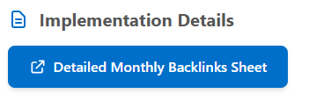

Key Findings

- The backlink profile continues to maintain strong domain quality, with approximately 90% of referring domains having a DA between 41–100.
- Page authority improved across both informational and commercia
l pages, with notable gains in the remote support, remote desktop, and patch management categories.
- Competitor keyword category continues to gain search visibility, with 5 keywords securing top 10 positions.
- Patch management and endpoint management keywords showed strong ranking gains, with both keywords reaching the top 5 positions.

LLM Highlights:
- Strongest AI Visibility Across Key Categories

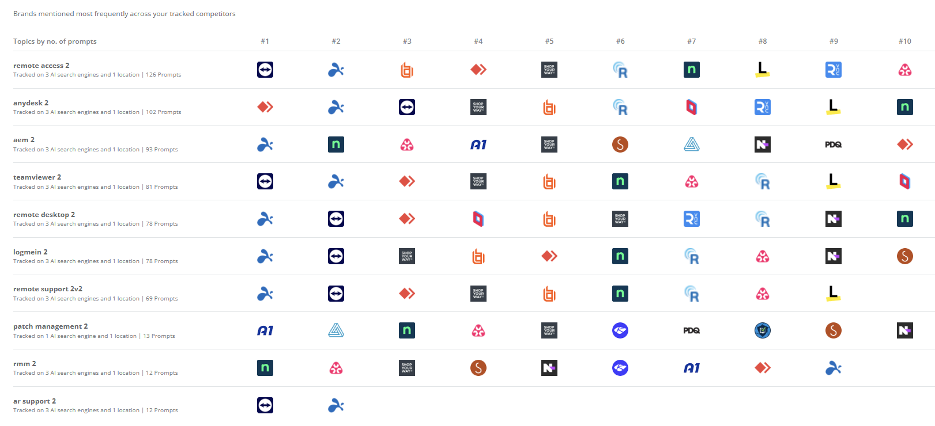

Splashtop achieves AI visibility across 9 of the 10 tracked priority topics, with Top 2 positions across 7 topics, demonstrating broad and consistent presence across key solution categories.

- Leading AI Brand Mention Share for “Remote Desktop”
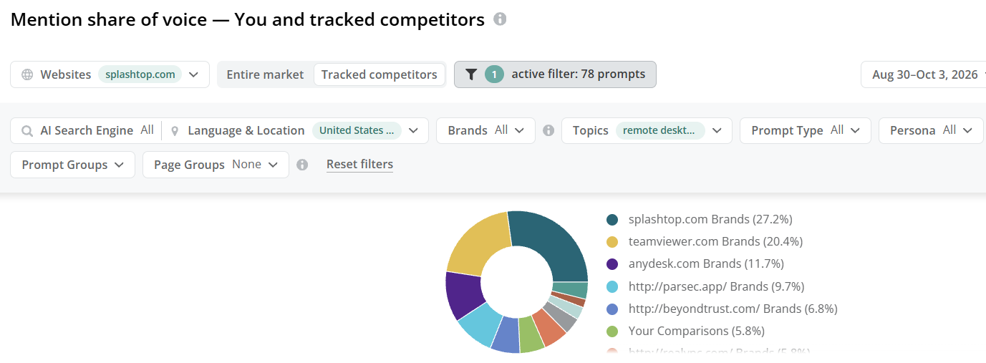

Splashtop holds the highest AI brand mention share at 27.2% for “remote desktop,” outperforming tracked competitors and demonstrating a leading presence in AI-generated responses for this business-critical topic.

- Dominant AI Brand Presence in AEM

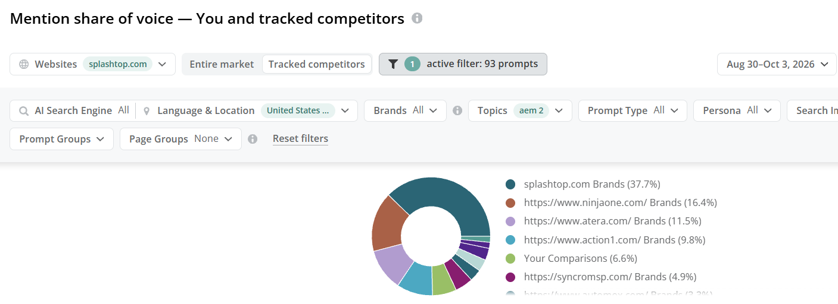

Splashtop captures 37.7% of AI brand mentions in the AEM category, more than 2x the next competitor, highlighting a significant lead in AI-generated AEM discussions.
- Strong AI Citation Leadership in Remote Access

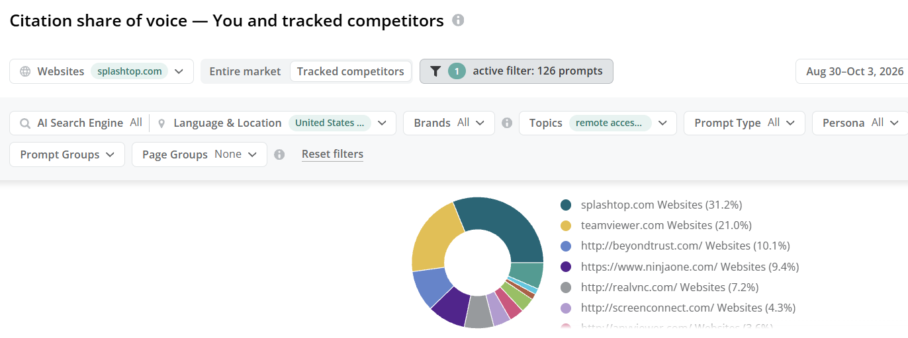

Splashtop accounts for 31.2% of AI citations in the Remote Access category, the highest share among tracked competitors, reinforcing its authority in AI-generated responses.

- High AI Citation Share in Remote Support
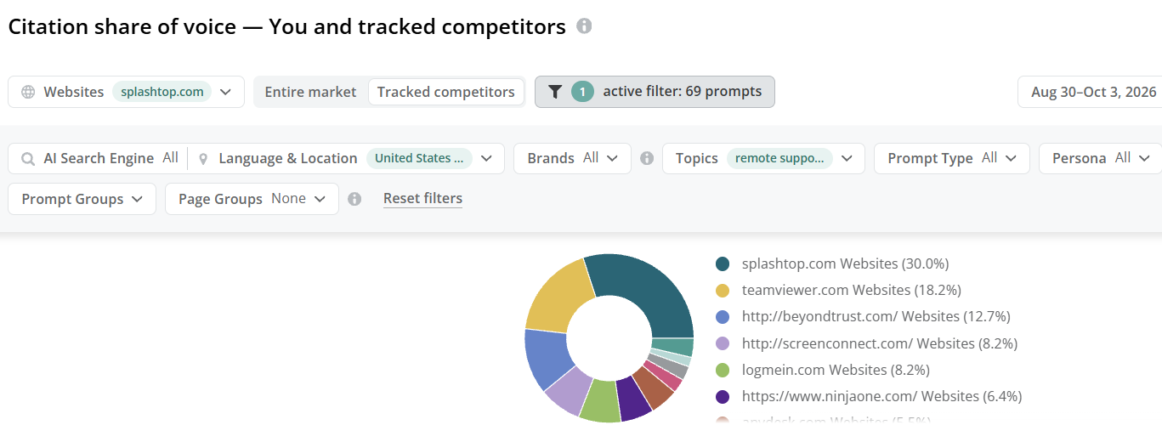
Splashtop captured 30.0% of AI citations for Remote Support, 1.6x the share of the next competitor, highlighting a substantial lead in AI-generated visibility for the category.

Highlights

- Sustained Top 5 Visibility for “Remote Access”

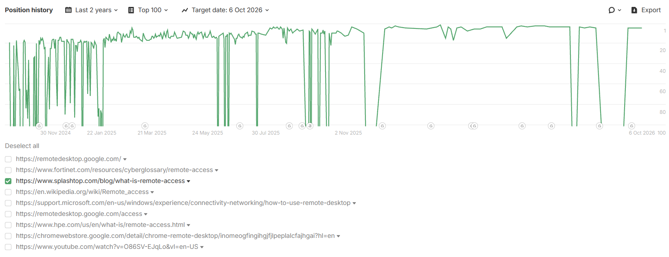

Splashtop has sustained Top 5 visibility for “remote access” over the past few months. Following a recent dip during the spam update, the keyword has recovered to the Top 5, supported by consistent high-quality backlink acquisition.

- “TeamViewer Pricing” Regains Top 5 Stability

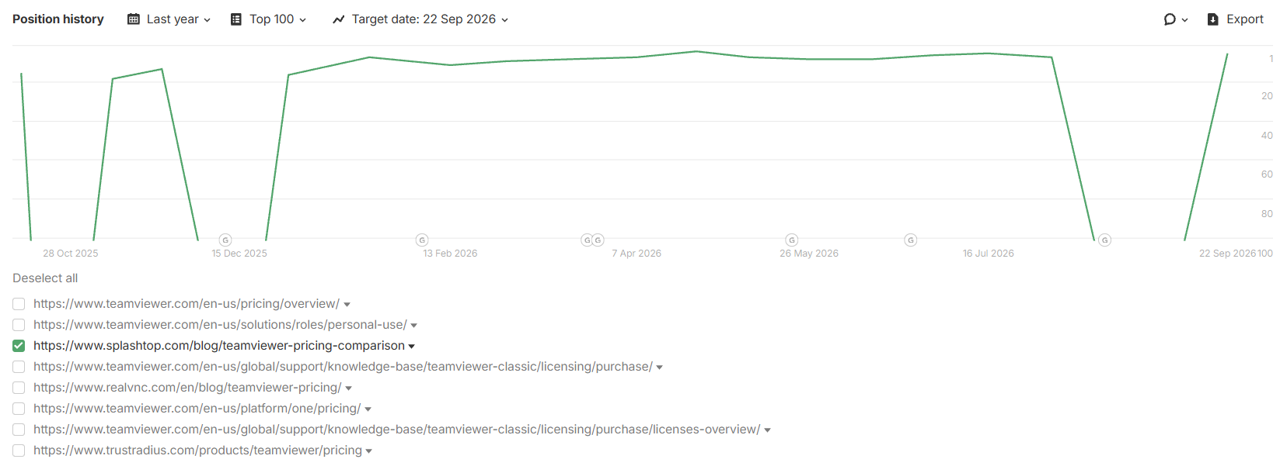
Splashtop’s “TeamViewer pricing” keyword has regained Top 5 visibility after a temporary decline following the spam update and has remained stable, supported by consistent high-quality backlink acquisition.

- Stable Top 5 Performance for “LogMeIn Alternative”

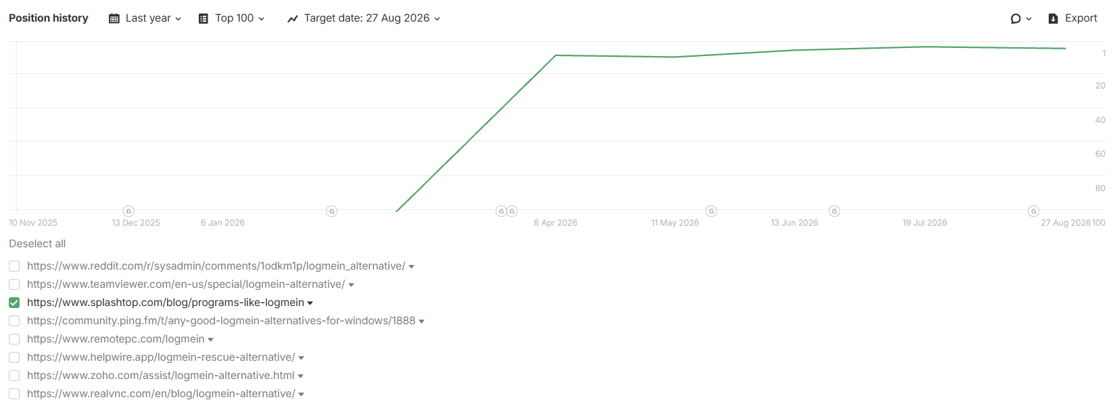
Splashtop’s “LogMeIn alternative” page has moved from outside the Top 100 to sustained Top 5 visibility, with the ranking remaining consistently strong following the initial improvement.

